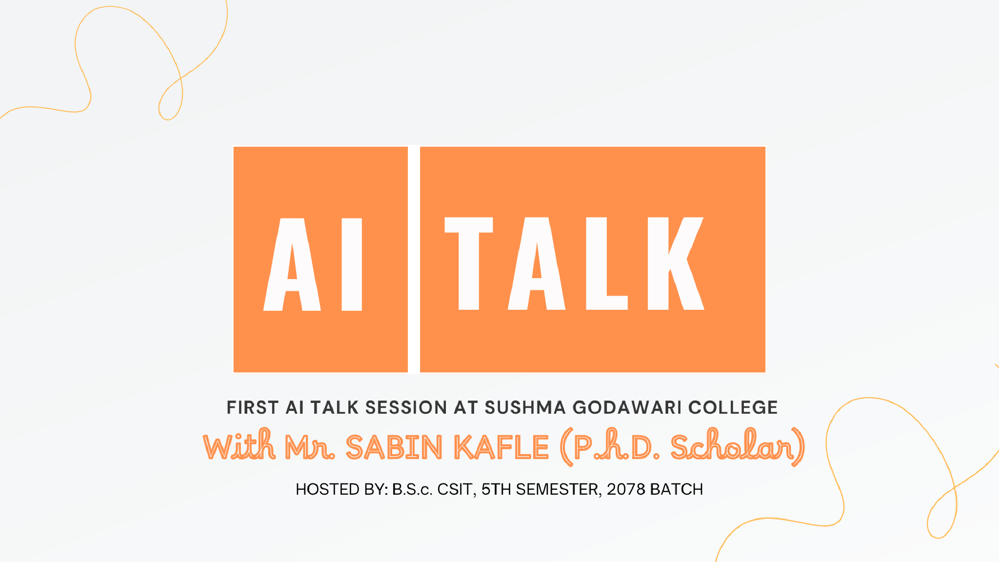

AI TALK

SHOW

# About Session

AI Talk is a dynamic session hosted by a B.S.C. CSIT 5th-semester Student at Godawari College. This engaging talk show, spanning 1 hour to 1 hour 15 minutes, will feature a guest speaker answering predefined questions and Q.N.A. about artificial intelligence, posed by the program host. The audience will consist of B.S.C. CSIT students from all semesters.

AI Talk Show Details

**Organizer/Hosted By**: 5th Semester B.S.c. CSIT 2078 Batch

**Main Guests:** Principal of Sushma Godawari College, CSIT Department Administrators

**Guest Speaker:** Assistant Professor. Sabin Kafle (Ph.D. Scholar, Visiting Faculty at Godawari College)

**Venue**: Godawari College Conference Hall

**Host:** Anup Adhikhari, Aruna Thapa **Date Time:** 6th Shrawan Sunday, 8:30 AM



# Objective:

The primary goal is to initiate and conduct the AI talk show for the first time, providing students with a valuable experience. The session aims to introduce and gain insights and knowledge by diving into the world of AI, fostering a deeper understanding of the field, and covering topics from basics to advanced.

Depth Discussion:

Raise of the AGI, the Future with AGI, Existential Risks, Consciousness: A Mystery

Session Setup:

* Guest Speaker and Host sit facing each other and the audience on stage.
* Ensure speakers and microphones are ready.
* Use a projector or smart TV for demo presentations and displaying questions.

Show Format:

* Host Brief about the talk show, organizer, guests, guest speaker & session (2-3min)
* Host Introduce the Guest Speaker (1min)
* Guest Speaker Speaks about himself/herself or delivers a short speech (5-10min )
* Talk Starts (25 - 30min)
* Demo of the AI/ML Model Application by Dilli Hang Rai (RNN ~ Positive or Negative Review, Supervised Algorithm Cloth Classifier) - 10-15 min
* Q.N.A Session (5 - 10 min)
* End of the Show



Questions:

1. Understanding AI:
   * What is AI? What can be called True AI?
   * Has AI been hyped?
   * What are the Differences between AI, ML, and DL?
2. AI and Humanity:
   * Is AI a threat to humanity? If yes, how? If not, why not?
3. Artificial General Intelligence (AGI):
   * What is AGI? When will we achieve AGI?
   * What is consciousness? Will machines ever achieve consciousness? What happens if they do?
4. AI Models and Applications:
   * What is an AI Model? How does ChatGPT work?
   * Applications of AI in different fields: present and future.
5. AI Ethics and Society:
   * AI Biasness and its impact, Ethical considerations in AI.
   * AI's effect on societal values.Job cuts due to AI, what if AI Starts to learn and do coding by itself?
   * How will AI shape the future?
6. Current Research and Career Paths:
   * What is the current status of research in AI?
   * How someone interested in AI should start to become or pursue their career as an AI/ML Engineer or Researcher?
   * What are the current challenges in achieving AGI, and how are researchers addressing them?
7. Education and Career in AI:
   * Many individuals have achieved significant success in the IT industry without possessing formal higher education. Do you need a computer science/engineering college degree to work in the IT industry and AI field? If yes, why? If not, why not?
   * There are always rumors, concerns, or complaints about outdated courses. Is T. U B.S.c CSIT/Computer Engineering Course Outdated?

Depth Discussion:

Raise of the AGI, the Future with AGI, Existential Risks, Consciousness: A Mystery